CAECOCOLIC INTUSSUSCEPTION and resultant CAECAL DILATATION in a cow

A cow was presented with history of not passing dung since 4 days..

Bilateral enlargement of ventral quadrants was seen.

Per rectal examination revealed balloon like structure indicating caecal dilatation.

Dark tarry liquid type of contents smeared the gloves..

Auscultation and percussion showed clear ping sounds in right flank at at some points of 12th , 11th and 10th intercoastal space..

Bulging at right flank was noticed..

Tentatively it was diagnosed as CAECAL DILATATION/ intussusception..

Right flank laparatomy was performed under paravertebral nerve block and inverted L block..

Enlarged caecal loop was taken out and an incision was given on it..

Large quantity of semisolid contents were evacuated by squeezing the caecum..then incision wound on caecaum was closed..complete exteriorization of caecum was not possible because of adhesions..

Then hand was inserted again in to abdomen to search for other pathologies..

A large mass was palpated..

Abdominal incision was extended and whole mass was exteriorized and it was identified as CAECOCOLIC INTUSSUSCEPTION...

Unlike intussusception at other parts of intestine, it was tough to excise INTUSSUSCEPTION part at this site as loops of colon were coiled with each other and caecum was involved in INTUSSUSCEPTION..

First longitudinal incision was given on the mass, little part of intussusceptum was found and removed..

Then other incision was given on the mass..large part of intussusceptum came out of it..

Then entertoanastomosis was performed using catgut by simple continuous pattern..

Pre operatively antibiotics and anti inflamatories, potassium chloride , fluid therapy ( 2 liters NS ) were given..

Animal passed watery greenish dung on next day..

Its 4 days over now after surgery..animal doing good..hoping for the better recovery..

Surgery was conducted by myself with Dr. Basavesh Hugar sir, Deputy director, Polyclinic,Shimoga along with Dr. Deepak A V

and Dr.Rudresh...it was a great opportunity to learn from Dr. Hugar sir..

Large quantity of semisolid c…

Swelling in the right flank👆

CAECOCOLIC INTUSSUSCEPTION and resultant CAECAL DILATATION in a cow

A cow was presented with history of not passing dung since 4 days..

Bilateral enlargement of ventral quadrants was seen.

Per rectal examination revealed balloon like structure indicating caecal dilatation.

Dark tarry liquid type of contents smeared the gloves..

Auscultation and percussion showed clear ping sounds in right flank at at some points of 12th , 11th and 10th intercoastal space..

Bulging at right flank was noticed..

Tentatively it was diagnosed as CAECAL DILATATION/ intussusception..

Right flank laparatomy was performed under paravertebral nerve block and inverted L block..

Enlarged caecal loop was taken out and an incision was given on it..

Large quantity of semisolid c…

Swelling in the right flank👆

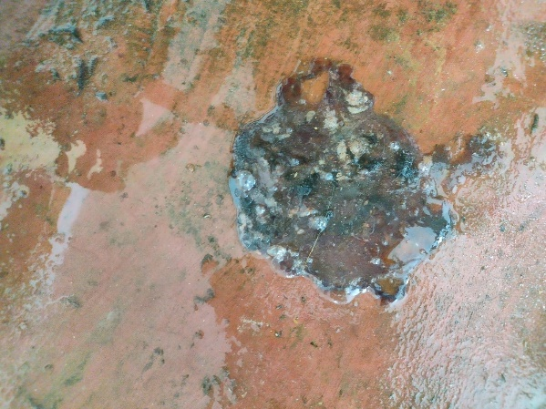

Mucus and black material was only voiding since 4 days👆

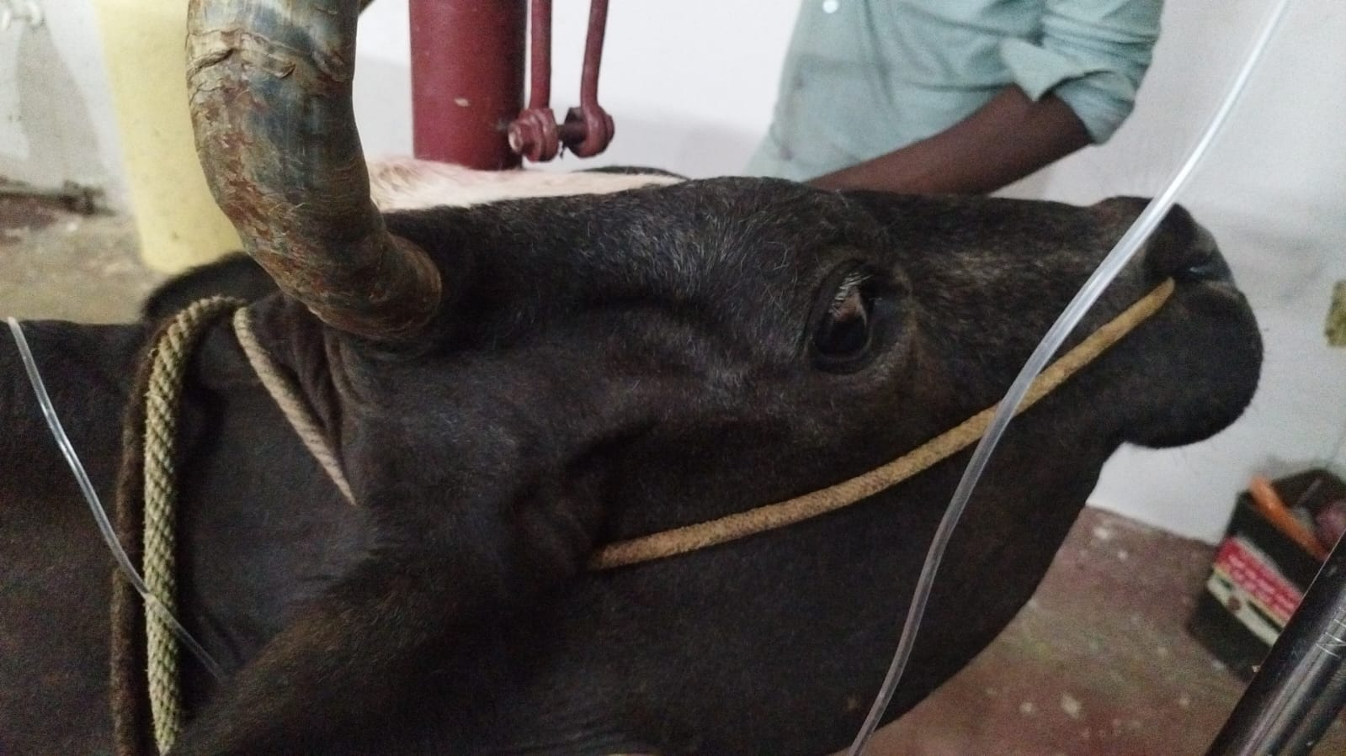

Severe dehydration👆

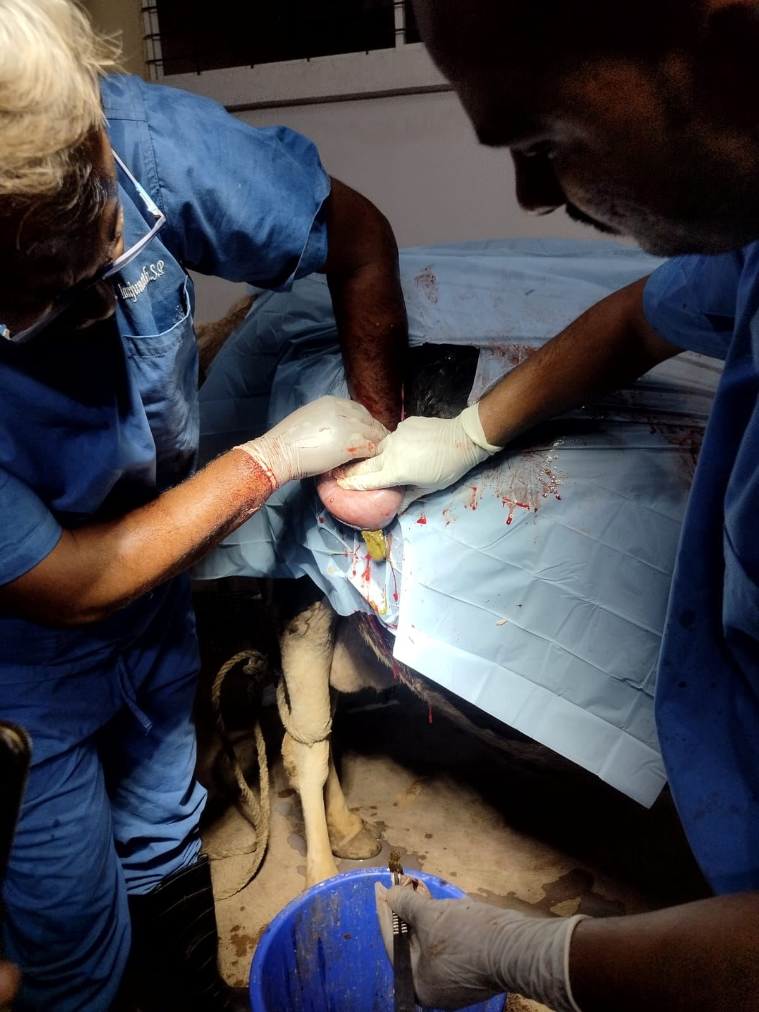

Typhlotomy..more than 15 liters semisolid contents were evacuated👆

CAECOCOLIC INTUSSUSCEPTION👆

CAECOCOLIC INTUSSUSCEPTION and resultant CAECAL DILATATION in a cow

First incision on the INTUSSUSCEPTION mass ( usually whole mass will be excised..but here it was not possible..hence incision was given on the mass)..only little necrosed intestinal loops came out👆

Second incision on the INTUSSUSCEPTION mass👆

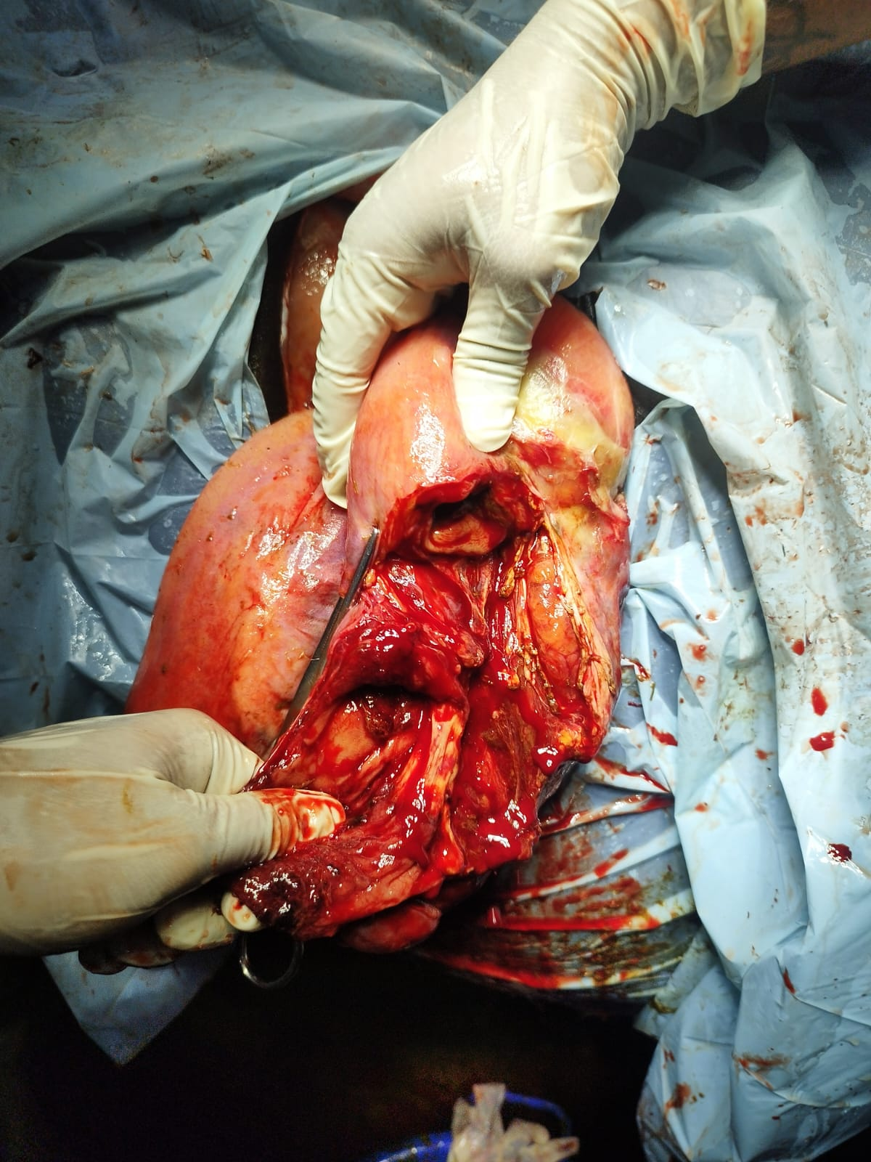

2 ends for anastomosis..(both the ends were thickened.. But it was not possible to go till getting normal thickness intestines)👆

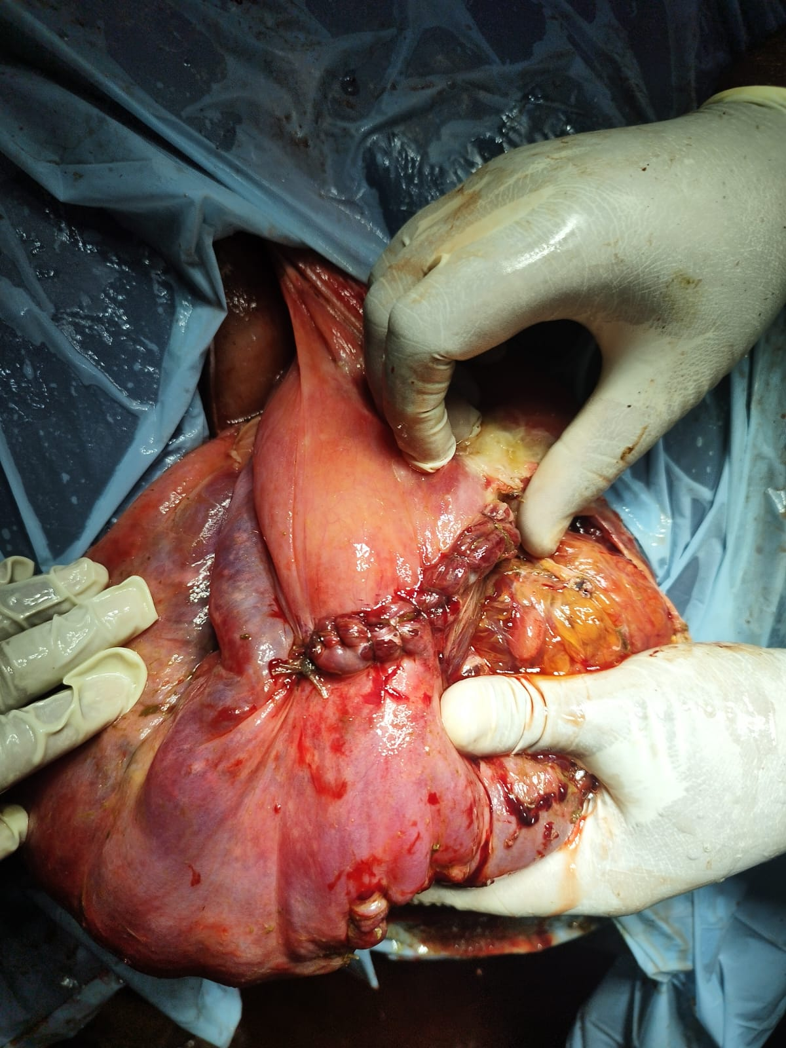

Enteroanastomosis👆

Animal passing greenish dung..video taken on 3 rd day after surgery👆

Typhlotomy..more than 15 liters semisolid contents were evacuated👆

CAECOCOLIC INTUSSUSCEPTION👆

First incision on the INTUSSUSCEPTION mass ( usually whole mass will be excised..but here it was not possible..hence incision was given on the mass)..only little necrosed intestinal loops came out👆

Second incision on the INTUSSUSCEPTION mass👆

2 ends for anastomosis..(both the ends were thickened.. But it was not possible to go till getting normal thickness intestines)👆

Enteroanastomosis👆

Animal passing greenish dung..video taken on 3 rd day after surgery👆